**College of St. Benedict & St. John’s University**

**Computer Science Department**

**CMC.com**

**Phase 2**

Team Name: xXPhantom Commander$Xx

Team Leader: Andrew Breyen

Team Members: Peter Gathje, Gavin Wollenberg, Andrew Breyen, Matt Rotter, Zachary Heinen, and Sam Young

Date: 3/19/2019

[This page is intentionally left blank]

# Table of Contents

Table of Contents 3

Task Decomposition 4

Screenshots of sent emails: 5

Meeting Minutes 6

February 25th 6

February 26th 7

February 26th 8

March 10th 8

March 11th 9

March 12th 10

March 13th Meeting with Imad 11

March 14th 11

March 17th 12

March 18th 12

March 19th 13

# Task Decomposition

Andrew: 15%  
Zach: 23%  
Matt: 15%

Sam: 15%

Gavin: 15%

Pete: 17%

See Meeting Minutes for more details.

# Class Diagram

Please view the class diagram on our GitHub page for a larger version:

<https://github.com/xxphantomcommander-xx/CSCI230_CMC_xXPhantom/blob/master/ClassDiagram.pdf>

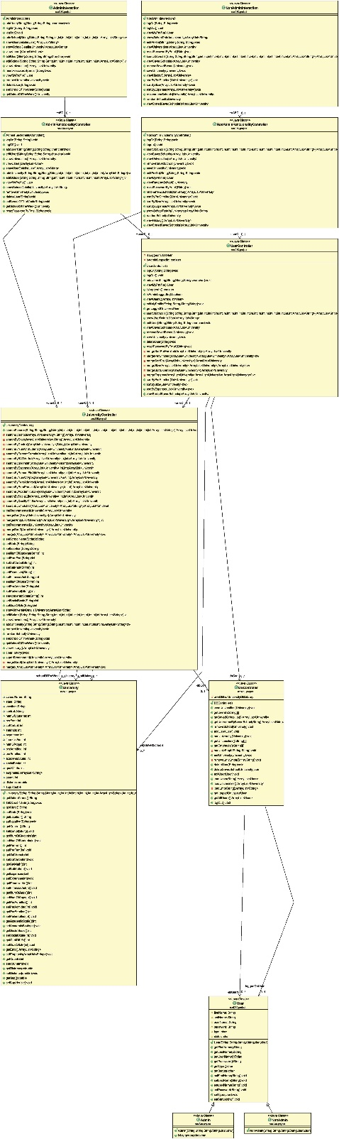

# Screenshots of sent emails:

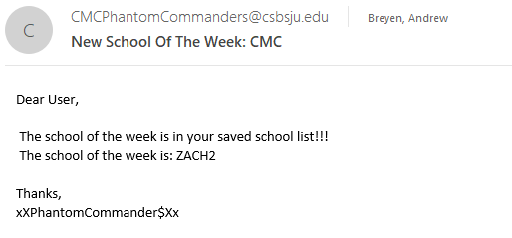

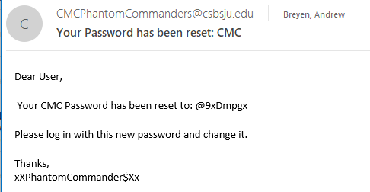

# Meeting Minutes

## February 25th

Met in the Pat 3 Computer Lab from 7:00 – 9:00

People Present: Andrew, Pete, Gavin, Sam, Matt, Zach

Started skeletons for programs below:

**Skeleton Implementation Sign Up:**

Admin: Pete

AdminFunctionalityController: Sam

AdminInteraction: Zach

DBController: Pete

NonAdmin: Pete

NonAdminFunctController: Matt

NonAdminInteraction: Zach

Picture: Gavin

University: Zach

UniversityController: Andrew

User: Gavin

UserController: Andrew

**Implementation Sign Up:**

TODO: To be DONE and APPROVED by March 13th.

1. (Admin and User) login: successful, failed due to invalid credentials and failed to due to inactive status: Gavin DONE
2. view and edit profile: Sam – (Non Admin), DONE
3. (User) search for schools by a combination of state and number of students and view search results : Zach
4. (User) find top 5 recommended schools for a given school: Pete
5. (Admin) view list of universities: Matt DONE
6. (Admin) view list of users: Andrew DONE

We began implementing methods outlined in the meeting schedule. Everyone claimed methods to do on our own time. (See list above)

Meeting Minutes Approved verbally 10:00 PM

## February 26th

Met in the Pat 3 Computer Lab from 7:00 – 9:30

People Present: Andrew, Pete, Gavin, Sam, Matt, Zach

We began this meeting by trying to set up our classes for the CMC software. We didn’t get very far before we ran into a lot of problems. It took us a while to try and figure out git hub, but we weren’t getting very far on it. Our goal was to work on the methods that need to be done for next Wednesday, however we never got around to it due to our many complications and questions. Here is a list of our questions that Andrew, Gavin, and Zach will bring to a meeting with Imad on   
Tuesday:

Questions for Imad:

1. How to **implement the database**?
   1. I think that this will mainly be used in the DBController, right?
2. **Main Method**?
   1. Why won’t it run. When we created a main method through Eclipse it said that there is not a main method.
3. **GitHub**?
   1. Are we doing it right? Can we just upload the entire project folder?
4. How to **get the project FROM GitHub and onto a Linux VM** for editing/usage
   1. Clone vs Pull, My understanding was that you cloned it the VERY first time you were going to download from GitHub, and pull all other times after that

We decided that without these questions answered we could not go on any further. We were beating ourselves up for things that we didn’t know about, and not much progress was made unfortunately. Our plan for the next meeting is to recap what Imad goes over with some of our members and try to begin working on these methods for the Wednesday after spring break.

Meeting Minutes Approved verbally 9:30 PM

## February 26th

Met in the Pat 3 Computer Lab from 7:00 – 8:00

People Present: Andrew, Pete, Gavin, Sam, Matt, Zach

This meeting began with a recap of the meeting that Zach, Gavin, and Andrew had with Imad. We all had to redo our github repository because we had realized we did it all wrong. It took a while for everyone to get it right, and we ran in to several problems. However, we eventually figured it out and all got on the same page. Zach and Pete began trying to work on the search and recommend methods. Sam and Gavin worked on the log in method. Andrew and Matt worked on the view universities method. We think once we get a method working, the rest will be a lot easier to figure out. However, we are having a tough time just getting one method right. We all had to stop working on it early because of our upcoming test tomorrow in CSCI310. We plan to try and work on these methods over break if possible.

Meeting Minutes Approved verbally 8:00 PM

## March 10th

Met in the Pat 3 Computer Lab from 6:00 –9:00

People Present: Andrew, Pete, Gavin, Sam, Matt, Zach

Sam, Zach, Pete, and Matt were here at the start of the meeting.Over break, Zach completed the Data Base Controller. So, to begin our meeting, we went over what was done. Then we began to tackle our 6 methods for Wednesday. We choose to work on the logon first because we figured you can’t do anything without logging on first. We followed our communication diagram to try and help implement this method. We first wrote out some pseudo code on paper before we tried to type out the code in Eclipse. Once we had come to agreement on the pseudo code, we began to implement it. Matt had to leave at 7:15, but that is when Andrew and Gavin showed up, as they had just gotten back on campus from Spring break. We then caught them up on what we had done and where we were going next. Then, we finished up the logon method. We believe what we have written is working and functional in a text-based system. The next method we moved on to was the view universities and view users methods. These methods will just be calls that essentially work their way up from the DBController. However, we made loader methods that takes all our users and universities and loads them into Users and Universities instead of strings. We concluded the meeting by planning for when to meet tomorrow, as well as a rough idea of how the rest of the week looks for us from a project standpoint.

Meeting Minutes Approved verbally at 9:00

## March 11th

Met in the Pat 3 Computer Lab from 3:00 –5:40 and 6:30 – 9:30

People Present: Andrew, Pete, Gavin, Sam, Matt, Zach

We decided to start today’s meeting by making a driver class to test what we had already done. Andrew, Pete, Sam, and Matt worked on the driver while Gavin and Zach began to work on the more difficult search method. As we were making the driver class, we realized that none of the methods we had done were working like we wanted them to. As a result of that, we had to go back and update and change all of our current methods. We first went back to finish a working logon method. At this point, Gavin, Zach, and Matt all left at 5:00 due to previous obligations. Andrew, Sam, and Pete stayed to work on the logon method/driver class up until dinner. At 5:40, Andrew, Sam, and Pete departed for dinner, with an agreement to meet back in the Pat 3 lounge at 6:30 to put the nose back to the grindstone. When we returned, we finished up the logon method and got it to work. We then moved onto the view/edit profile methods. This didn’t work either. Again, we had to make modifications and changes to get it to work like we wanted to. This consisted of moving the methods to the UserController class and changing said from Abstract to a normal class. We did this to simplify our connection between the NonAdmin, Admin, and User classes. We removed all the getters and setters from Admin and NonAdmin. Then we had to change our loadUsers method because almost everything we did after that will run through it one way or another if it involves messing with user related methods. Then, we proceeded to actually make our view and edit profile methods. These methods intially tripped us up because we used == instead of .equals() to compare Strings. However, we found that mistake eventually and it resulted in a success through the Driver class. To double check this, we ran our driver and refreshed the online database. To our excitement, the database had been updated just like we wanted it to. Next, we moved onto the view Users method. This too did not work. Gavin returned at 7:45 from his prior obligation to help us for the rest of the meeting. Our problem this time was trying access elements from the 2D array. To fix this problem, we made an ArrayList of Users that only took in the name. To get this, we again had to go through the loadUsers method. Eventually, we debugged it all and got it to work through the driver class like we wanted to. Finally, we moved onto the view Universities method. To accomplish this, we had to model our loadUniversities method after our loadUsers method. However, we forgot to add the element of a university’s control in the constructor, which messed everything up. We fixed that and added it to the constructor, and then we made a viewUniversities method. This method ran through our loadUniversities method to get all its needed information. After a lot of debugging, we finally got all of the schools to display like we wanted them to through the driver. Once we finished that method, we decided to call it a night, with the agreement that we would meet tomorrow to finish the search and recommend schools method.

Meeting Minutes Approved verbally at 9:30

## March 12th

Met in the Pat 3 Computer Lab from 4:00-9:10

People Present: Andrew, Pete, Gavin, Sam, Matt, Zach

Pete and Zach worked on the Search Schools method.

They modified the current outline that was set up at the last meeting to fully accommodate everything and to work correctly.

They then worked on the driver program to make sure that that method worked, and the driver worked with it.

Matt, Sam, and Andrew started work on the 5 recommended schools. Sam started with trying to flesh it out on paper, but we began to realize that there are a lot of helper methods and it will start to take a lot of work to write it. Sam and Matt went to go get dinner briefly. We then transitioned to working on it on a computer after Pete and Zach got it to work.

Pete and Zach finished the recommended schools before Sam and Matt returned from dinner. Once the Search School method was complete, Andrew, Sam, Pete, Zach, and Matt worked on the Top 5 Recommended Schools method. Sam brainstormed an idea to create a count variable and increment that based on if the school that we are comparing to is the same as (for strings) or within a specified range (for ints) We first used a TreeMap, but were unable to get the associated school (key) with the number of associations (value). Our final implementation created an ArrayList of all of the universities, sorted them numerically.

Gavin returned at 8:23 PM

We used Eclipse, along with ObjectAid (documentation for that at <https://github.com/xxphantomcommander-xx/CSCI230_CMC_xXPhantom/wiki/Generating-UML-Diagrams-with-ObjectAid>) to recreate the Class Diagram.

Meeting Minutes Approved verbally at 9:10

## March 13th Meeting with Imad

Everyone present

Logged on user is special for the class diagram????

Imad Notes/Things to change:

* Instance fields need documentation
* Tags are all there could use more verbiage.
* Move the load universities and load users to the university database.
* Pass user or university object to add or edit the user.
* Log on GOOD
* Edit profile GOOD
* View my profile GOOD
* Search schools GOOD, but double check that we have all the search parameters in the correct order.

Recommend top 5 RE-DO with the examples.

Instead of counting we need to add the differences

Maybe use our current recommended schools as an extra feature?

Enhanced version of recommended search: gets the first five matching schools from each recommended to get the most similar recommended.

Once the meeting with Imad was over, we transitioned to working in the Pat 3 lounge. Andrew, Gavin, matt, and Sam started looking over the new way to recommend schools.

Zach and Pete went to fixing what we slightly missed for the meeting with Imad, going down the list to fix everything.

## March 14th

Members Present: Zach, Pete, Andrew, Sam, and Matt

Met in the Pat 3 Computer Lab 6:00 – 8:00 PM

Zach worked on coding a multitude of required functionalities, including add saved school, get saved school list, delete saved school, edit user, edit university, view one user, and view one university. These have yet to be tested but will work on the first try 100%.

The rest of us worked on debugging the errors from previously working methods. The load users and load universities had been previously moved to the DB controller, and has caused problems getting those methods to work properly again in the driver. We got the driver to view all the universities, but are unable to get a list of all the users. The error is a null pointer exception, and that means that it believes that the list of users is empty when it should not be. We’ll figure it out eventually 🙂 debugging is very fun and it’s a great learning experience.

Meeting Minutes verbally approved 8:15 PM

## March 17th

Members Present: Zach, Pete, Andrew, Sam, and Matt

Met in the Pat 3 computer lab 6:00 – 8:00

Everybody banned together onto one computer to work on what we have left in the driver and organize it better. Zach first took control of the main computer and started to work.

We commented out the methods that took a while to run but we knew it worked. Zach coded Logon, add edit remove universities, view and view details of universities, add edit view user. Added random university and school of the week to our code and to the driver.

We finished all the admin interactions. There are a few to do for a non admin by Wednesday. It is all on Sam's desktop.

Meeting Minutes verbally approved 8:15 PM

## March 18th

We started working on completing all functionalities.

Matt and Gavin worked on getting images for all the schools. They were saved as UNIVERSITY NAME.jpg and were pushed to GitHub. In the GUI version, we will be able to use the university name + .jpg. The images were saved to /eclipse-workspace/CSCI230_CMC_xXPhantom/pics folder and uploaded to our GitHub team for distribution amongst our team.

Andrew and Zac started on the email reset password. We created a gmail account to send/receive emails. We used a tutorial found at <https://www.javatpoint.com/example-of-sending-email-using-java-mail-api> to create a method to send the email. More external JARs were required, which we downloaded and added to Eclipse. The external JARs have been uploaded to our GitHub team for distribution amongst our team.

Sam and Pete worked on finalizing the Top 5 Recommended method, using the mathematical distance version. They struggled with getting the distance value to be the correct one. At first, we ran into the issue of the distance being 190, then the distances were 0.0 for all the recommendations. After some tweaking we realized that Integer Division

We finished all the implementations, and reorganized the Driver class

Gavin worked on implementing the Picture class

**Questions for Imad:**

Extra parameters for recommend: is this OK? Can we set them to zero w/o needing them to be a University parameter?

University of Zac issue: Database updates with information but when we continue to run the Driver, the updated information is not displayed

Extra Functionality: Super Search to replace images?

## March 19th

Present: Sam, Matt, Pete, Zach (Gavin and Andrew joined later)

Met in Pat 3 lounge at 1:00-8:00

Attendance: Sam left at about 3:15 and came back at around 4:30, and also left from 6 to 7. Pete left at 4:20 and came back around 6. Zach left at 5:30 and came back around 6. Andrew had class until 4, left at 6, and came back at 7. Gavin had class until 7. Matt was present from 1 until about 5.

Coding changes: Started out by figuring out what we need to finish for Wednesday. We figured out that we have everything that is required and now we must work on our implemented ideas. The first one is adding the search history to the driver to test it to make sure it worked. We got the search history to work and began working on the view saved schools method. There were some issues getting this one to work, but we eventually got it and began to move on to the sorting saved schools functionality. The schools can successfully be sorted based on their number of students, percent enrolled, and expenses. After that we added a feature so school of the week will notify people by email if their saved school is the school of the week.

Other than the actual coding changes, we went through and added javadoc comments to every method and attribute that did not already have them, as well as deleted skeleton methods that we never ended up using. Most of these skeleton methods were in the admin and non-admin classes. After this was complete we began to modify the driver so that it is easier to read the outputs. Once that was completed, we got the javadocs onto a file/website, we got a text file containing the driver output, we got a readme file that describes how to run our driver. We put all of these into a file along with our actual code, our updated class diagram, and our phase 2 document so that everything is ready to be turned in.

We did it :)

Meeting Minutes verbally approved at 8:00 PM